Version <1.0>

Revision History

|  |  |  |  |
| --- | --- | --- | --- |
| **Date** | **Version** | **Description** | **Author** |
| <dd/mmm/yy> | <x.x> | <details> | <name> |
|  |  |  |  |
|  |  |  |  |
|  |  |  |  |

Table of Contents

1. Introduction 4

1.1 Purpose 4

1.2 Scope 4

1.3 Definitions, Acronyms, and Abbreviations 4

1.4 References 4

1.5 Overview 4

2. Positioning 4

2.1 Problem Statement 4

2.2 Product Position Statement 4

3. Stakeholder and User Descriptions 5

3.1 Stakeholder Summary 5

3.2 User Summary 5

3.3 User Environment 6

4. Product Requirements 6

# Introduction

[The purpose of this document is to collect, analyze, and define high-level needs and features of the <<System Name>>. It focuses on the capabilities needed by the stakeholders and the target users, and **why** these needs exist. The details of how the <<System Name>> fulfills these needs are detailed in the use-case and supplementary specifications.]

[The introduction of the **Vision** document provides an overview of the entire document. It includes the purpose, scope, definitions, acronyms, abbreviations, references, and overview of this **Vision** document.]

The purpose of this document is to collect, analyze, and define the high-level needs and features of the Restaurant Management System. The application is a client-server application designed for a restaurant to record orders, handle payments, and manage the activity of its employees. This document focuses on the capabilities needed by the stakeholders and target users, and why these needs exist. It provides an overview of the entire project, including its purpose, scope, definitions, acronyms, abbreviations, references, and overview of this Vision document.

## Purpose

[Specify the purpose of this **Vision** document**.**]

The Restaurant Management System is designed to provide an efficient and user-friendly solution for the restaurant's management of orders, payments, and employee activity. The system will allow waiters to record orders and handle payments while considering discounts based on a client's loyalty. It will also allow kitchen employees to send notifications to waiters when food is ready, and a manager to perform CRUD operations on employee information and check their activity. The system will store and manage information related to orders, clients, waiters, products, and employee activity.

## Scope

[A brief description of the scope of this **Vision** document; what Project(s) it is associated with and anything else that is affected or influenced by this document.]

## Definitions, Acronyms, and Abbreviations

[This subsection provides the definitions of all terms, acronyms, and abbreviations required to properly interpret the **Vision** document. This information may be provided by reference to the project’s Glossary.]

This section defines the key terms, acronyms, and abbreviations used in this document. It ensures that all stakeholders have a shared understanding of the terminology used in the <<System Name>> documentation.

## References

[This subsection provides a complete list of all documents referenced elsewhere in the **Vision** document. Identify each document by title, report number if applicable, date, and publishing organization. Specify the sources from which the references can be obtained. This information may be provided by reference to an appendix or to another document.]

This section lists the references used in the development of this Vision document. It ensures that all stakeholders are aware of the sources of information used to inform the application design and development.

## Overview

[This subsection describes what the rest of the **Vision** document contains and explains how the document is organized.]

The rest of this Vision document provides an overview of the Restaurant Management project. It includes the context of the project, the users of the system, the system features, and the key benefits that the system will provide to its stakeholders. It also provides a high-level overview of the system architecture and the development approach to be used in the project.

# Positioning

## Problem Statement

[Provide a statement summarizing the problem being solved by this project. The following format may be used:]

The problem of inefficient order and payment processing in restaurants affects both the customers and restaurant staff. Customers often face long wait times and errors in their orders, while restaurant staff struggle to keep up with manual order and payment handling, leading to decreased efficiency and customer satisfaction. A successful solution would streamline the order and payment process, improving the overall dining experience for customers and increasing efficiency and profitability for restaurant staff.

|  |  |
| --- | --- |
| The problem of | Inefficient payment and ordering processing |
| affects | Customers and Staff |
| the impact of which is | Long waiting time |
| a successful solution would be | Streamline the order and payment process |

## Product Position Statement

[Provide an overall statement summarizing, at the highest level, the unique position the product intends to fill in the marketplace. The following format may be used:]

|  |  |
| --- | --- |
| For | [target customer] |
| Who | [statement of the need or opportunity] |
| The (product name) | is a [product category] |
| That | [statement of key benefit; that is, the compelling reason to buy] |
| Unlike | [primary competitive alternative] |
| Our product | [statement of primary differentiation] |

[A product position statement communicates the intent of the application and the importance of the project to all concerned personnel.]

# Stakeholder and User Descriptions

[To effectively provide products and services that meet your stakeholders’ and users' real needs, it is necessary to identify and involve all of the stakeholders as part of the Requirements Modeling process. You must also identify the users of the system and ensure that the stakeholder community adequately represents them. This section provides a profile of the stakeholders and users involved in the project, and the key problems that they perceive to be addressed by the proposed solution. It does not describe their specific requests or requirements as these are captured in a separate stakeholder requests artifact. Instead, it provides the background and justification for why the requirements are needed.]

For restaurant owners and staff who want to improve their customers' dining experience and streamline their operations, the "RestaurantApp" system is a client-server application that allows for easy recording of orders, handling of payments, and management of employee activity in the restaurant. Unlike manual order and payment handling or other restaurant software solutions, our product offers real-time notifications for food readiness, automatic loyalty discounts, and comprehensive employee management features.

## Stakeholder Summary

[There are a number of stakeholders with an interest in the development and not all of them are end users. Present a summary list of these non-user stakeholders. (The users are summarized in section 3.2.)]

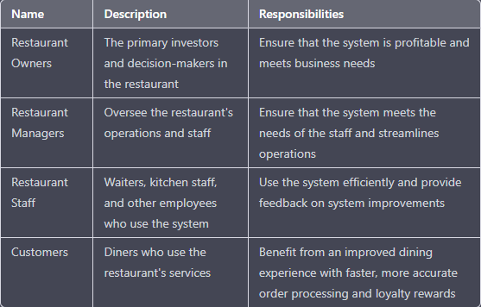

## User Summary

[Present a summary list of all identified users.]

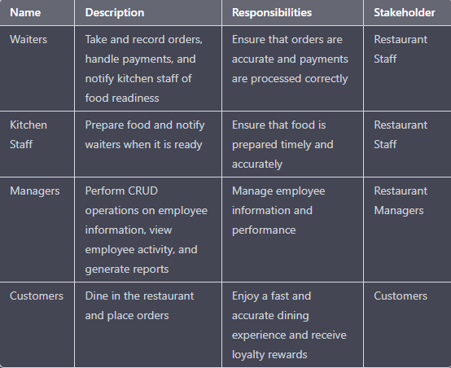

## User Environment

[Detail the working environment of the target user. Here are some suggestions:

Number of people involved in completing the task? Is this changing?

How long is a task cycle? Amount of time spent in each activity? Is this changing?

Any unique environmental constraints: mobile, outdoors, in-flight, and so on?

Which systems platforms are in use today? Future platforms?

What other applications are in use? Does your application need to integrate with them?

]

The target users of the "RestaurantApp" system work in a restaurant environment, which can be fast-paced and demanding. Waiters and kitchen staff need to be able to quickly record and process orders, while managers need to be able to monitor employee activity and generate reports. The system should be user-friendly and efficient, with minimal downtime or interruptions in service. The system will be used on desktop computers or mobile devices, and may need to integrate with existing restaurant software solutions.

# Product Requirements

[At a high level, list applicable standards, hardware or platform requirements, performance requirements, and environmental requirements.]

The "RestaurantApp" system should meet applicable standards for secure payment processing and data privacy. It should be compatible with standard desktop and mobile devices and operating systems. Performance requirements should include fast processing times for order recording and payment processing. Environmental requirements should include reliability and robustness to handle potential hardware or network failures.